**Test Case** **0052**

**System:** VirtuCardsHost and VirtuCardsClient

**Description:** [Create test cases that ensure songs are removed from the queue when players add more songs.](https://github.com/VirtuCard/VirtuCard/issues/368)

**Severity:** 3

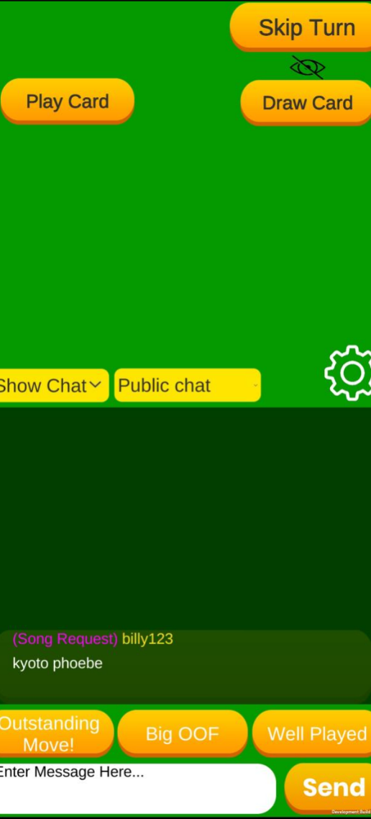Throughout the following test cases, the !play command is used. The usage is as shown below:

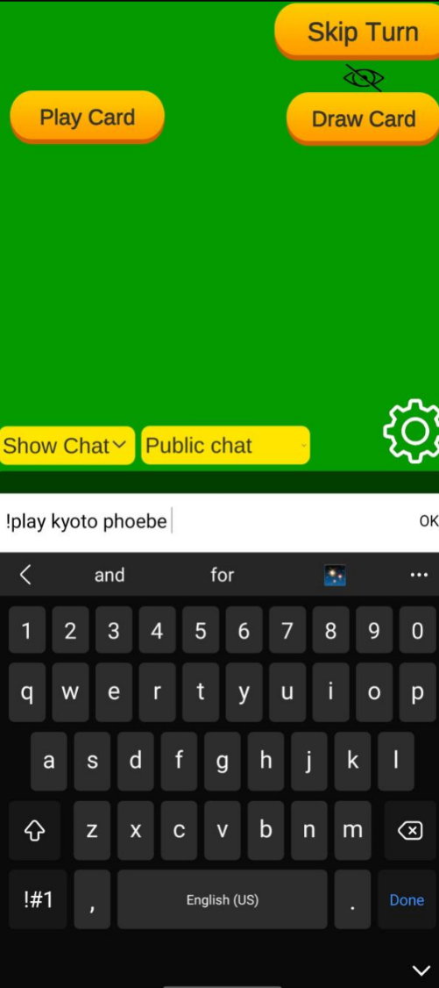

The result of the command is the input song name added to the Chat panel as a private message only visible to the user who sent it. It’s highlighted as a Song Request to distinguish these requests.

An example usage of the !play command, used in the chat during a game.

**Instructions**

**Test 1**

1. Start VirtuCardClient application
2. Click the button labeled “Sign In”
3. Enter “test@test0.com” into the text input labeled “Enter email…”
4. Enter “Password!123” into the text input labeled “Enter password…”
5. Press the button labeled “Login”
6. A window should appear saying “Login Success”
7. Press the OK button that appears on that window
8. Start VirtuCardsHost application
9. Choose a desired game mode
10. Click the Create Game button
11. Enter the displayed Join Room Code in the VirtuCardsClient application.
12. Press the Music button on the Host’s game screen.
13. In the chat on the VirtuCardsClient, use the play command to queue in a couple songs in the music panel.
14. Press the Skip button indicated by the l>| icon.

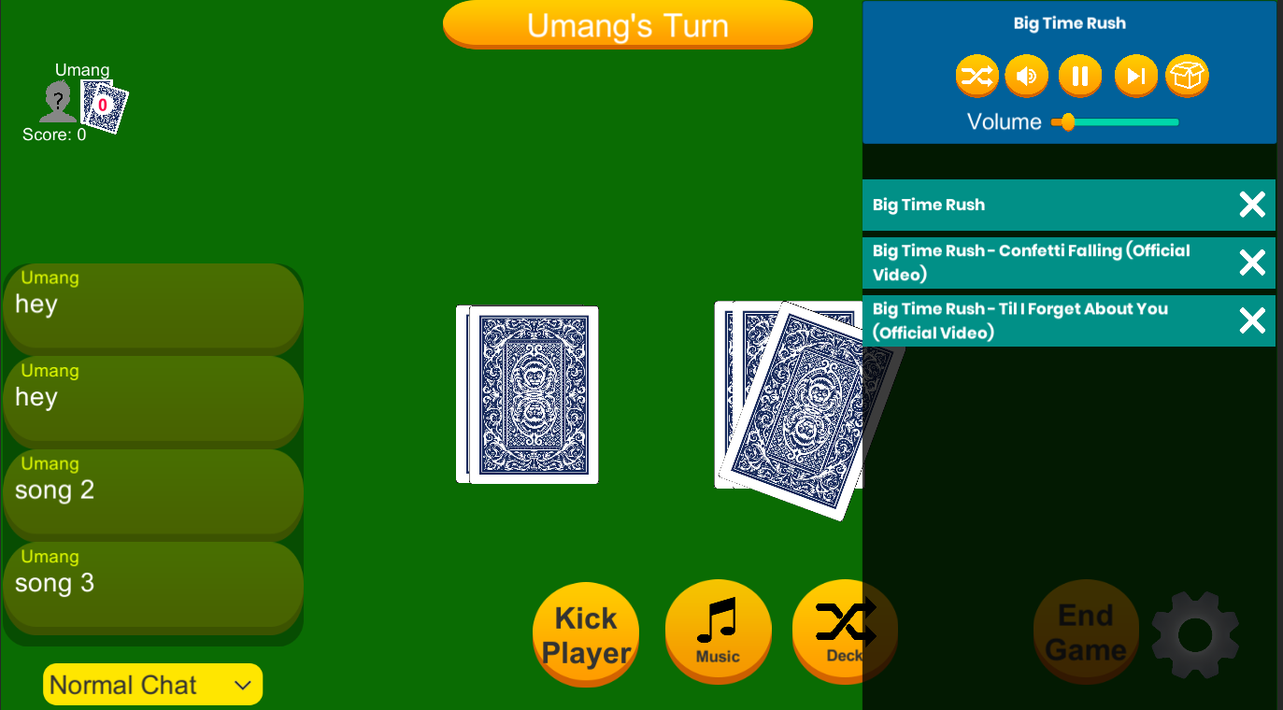**Expected Result:** The song that is currently playing should stop. It should be removed from the queue and the next song should start playing.

Three songs have been queued into the music panel.

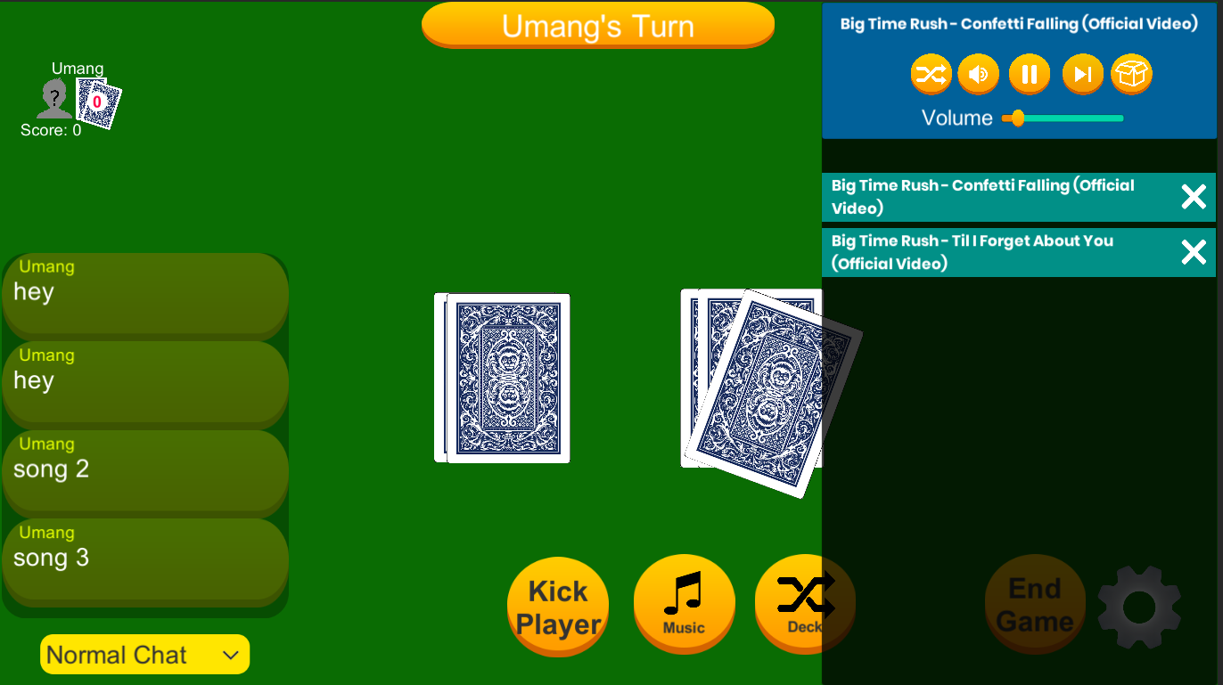

Pressing the Skip button has removed the first song that was playing from the queue.

**Test 2**

1. Start VirtuCardClient application
2. Click the button labeled “Sign In”
3. Enter “test@test0.com” into the text input labeled “Enter email…”
4. Enter “Password!123” into the text input labeled “Enter password…”
5. Press the button labeled “Login”
6. A window should appear saying “Login Success”
7. Press the OK button that appears on that window
8. Start VirtuCardsHost application
9. Choose a desired game mode
10. Click the Create Game button
11. Enter the displayed Join Room Code in the VirtuCardsClient application.
12. Press the Music button on the Host’s game screen.
13. In the chat on the VirtuCardsClient, use the play command to queue in a couple songs in the music panel.
14. Press the X button next to a song

**Expected Result:** The corresponding song will be removed from the queue. If the song is currently playing, the next song will begin playing.



3 songs have been queued into the music panel.

Three songs have been queued into the music panel.



Pressing the X button next to the first song has removed it from the queue and the next song has started playing.

**Test 3**

1. Start VirtuCardClient application
2. Click the button labeled “Sign In”
3. Enter “test@test0.com” into the text input labeled “Enter email…”
4. Enter “Password!123” into the text input labeled “Enter password…”
5. Press the button labeled “Login”
6. A window should appear saying “Login Success”
7. Press the OK button that appears on that window
8. Start VirtuCardsHost application
9. Choose a desired game mode
10. Click the Create Game button
11. Enter the displayed Join Room Code in the VirtuCardsClient application.
12. Press the Music button on the Host’s game screen.
13. In the chat on the VirtuCardsClient, use the play command to queue in a couple songs in the music panel.
14. Press the Clear All button indicated by the open box icon.

**Expected Result:** The music queue will be cleared and all music will stop.



2 songs have been queued into the music player.

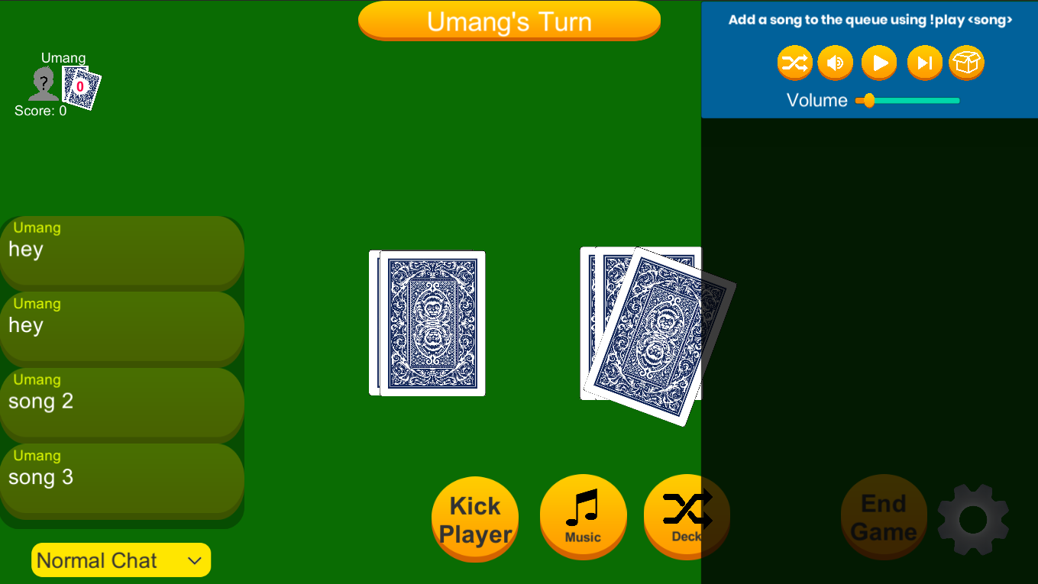

Pressing the Clear All button has emptied the queue.

**Test 4**

1. Start VirtuCardClient application
2. Click the button labeled “Sign In”
3. Enter “test@test0.com” into the text input labeled “Enter email…”
4. Enter “Password!123” into the text input labeled “Enter password…”
5. Press the button labeled “Login”
6. A window should appear saying “Login Success”
7. Press the OK button that appears on that window
8. Start VirtuCardsHost application
9. Choose a desired game mode
10. Click the Create Game button
11. Enter the displayed Join Room Code in the VirtuCardsClient application.
12. Press the Music button on the Host’s game screen.
13. In the chat on the VirtuCardsClient, use the play command to queue in a couple songs in the music panel.
14. Press the X button on all the songs

**Expected Result:** The music queue will be cleared and all music will stop.

2 songs have been queued into the music player.



Pressing the X button on both songs has emptied the queue and stopped all music.